Negotiating return to work in the age of demographic change through industrial relations (VS/2019/0075)
Ireland
General indicators for work incapacity, industrial relations and chronic disease*
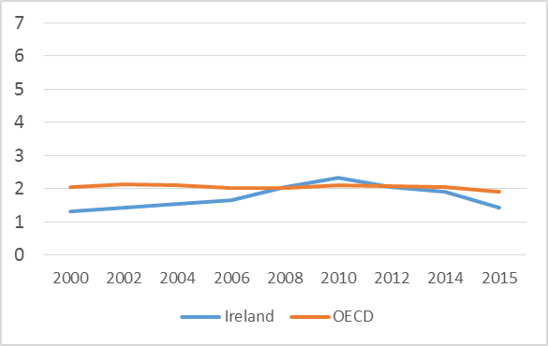 | 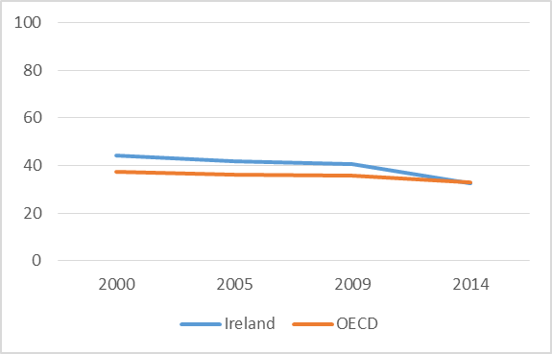 |  |  | 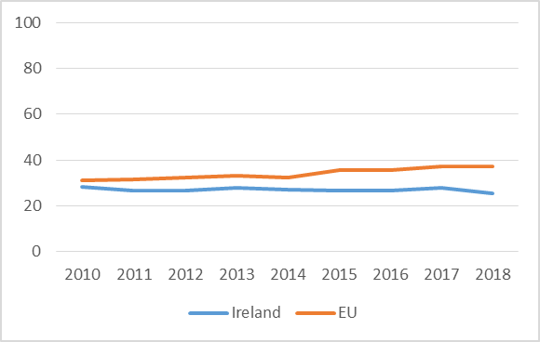
Public spending on incapacity (% of GDP) | Collective bargaining coverage (%) |  |  | Chronic morbidity (people having longstanding illness or health problems)
Policy framework and key issues for return to work
- No systematic support framework guiding the reintegration of employees with chronic illness back into the workplace at national level  - Where chronic illness is captured in policy and legislation, it typically comes under the umbrella of disability  - Policies and supports focus on the unemployed rather than employed workers with regard to return to work  - Key legislation: The Employment Equality Status Acts (1998-2015), Health & Safety at Work Act (2005), Unfair Dismissals Acts (1977-2015), Disability Act (2005), Industrial Relations Acts (1969, 1990, 2015) |  | - No national forum for stakeholder cooperation to facilitate discussion on return to work after chronic disease  - Lack of coordination mechanisms between key stakeholders to support the worker returning to work (e.g. between government agencies, health professionals, employers and the worker)  - No statutory right to an occupational sick pay scheme  - Limited vocational rehabilitation support  - Significant gap in government policy whereby people are required to be unemployed/inactive before they can avail of support
Policy framework |  | Key policy issues
Involvement of social partners in return to work policies
- Liberal market economy with voluntarist industrial relations  - Decline of national-level social partnership  - Some segmented national-level social dialogue on industrial relations issues  - Return to work after chronic illness is not a current priority area for national employers or union bodies  - Fragmented provision of RTW support and information |  | - Clear company policy templates developed for return to work often through absence management policies  - Good managerial communication procedures with employee from diagnosis and during sickness and recovery until ready to return to work  - Limited union involvement on RTW issues at company level in some cases  - Where collective agreements regulating the reintegration of workers following a sickness absence exist, these are generally effective  - RTW policies at company level should be annually reviewed  - Provision of training to HR and line managers on best practices on return to work with CIPD involvement  - Creation of company-level best practice champions on return to work
National level |  | Company level
Policy recommendations
Recommendations for policymakers  - Establishment of intergovernmental departmental body on creating an RTW national framework  - Development of national, integrated RTW framework with governmental, social partner and NGO/patient groups with clear actions, roles specified, responsibilities given and adequate funding provided  - Urgent need to introduce legislation to make sick pay an employment right for all workers in Ireland  - Systematic national collection of data on current RTW situation to identify gaps and future needs  - Work with government agencies, NGOs, employer bodies and unions on awareness-raising activities to support return to work after chronic illness |  | Recommendations for social partners  - Make RTW policies and discussions part of any national social dialogue  - Both national employers and union bodies should agree a systematic approach to return to work  - Create mechanisms to ensure involvement of NGOs and patient groups in national dialogue on return to work  - Create national comprehensive RTW framework with a centralised “one stop hub” for coordination, education and advice for workers and employers  - Increase focus on vocational rehabilitation supports to ensure timely intervention and support for return to work
Further information
References

*Sources: Data on public spending on incapacity and collective bargaining coverage is taken from the OECD. Chronic morbidity is taken from Eurostat.

The concept is operationalised by a question asking if the respondent suffers from any longstanding (of a duration of at least six months) illness or health problem.

