Negotiating return to work in the age of demographic change through industrial relations (VS/2019/0075)
Romania
General indicators for work incapacity, industrial relations and chronic disease*
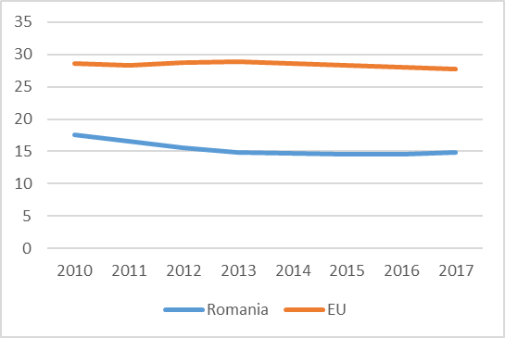 | 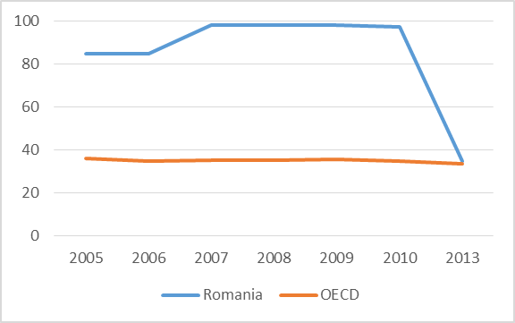 |  |  |  | 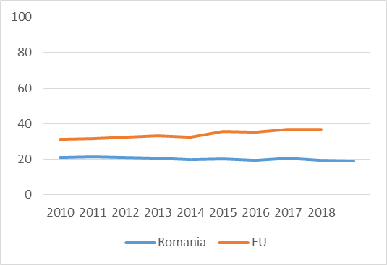
Expenditure on social protection  (% of GDP) | Collective bargaining coverage (%) |  |  |  | Chronic morbidity (people having long-standing illness or health problems) (%)
Policy framework and key issues for return to work
- Labour Code (Law 53/2003)  - Law 263/2010 (the unitary system of public pensions)  - Emergency Ordinance 158/2005 (temporary work incapacity and social health insurance)  - Government Decision 355/2007 (employees’ health monitoring)  - Law 448/2006 (on the rights of people with disabilities)  - Law 319/2006 (health and safety at the workplace) |  |  | - The policy contains general guidelines, in relation to benefits, eligibility and the period of entitlement  - There is no specific policy framework on return to work  - The main roles in return to work are allocated to health professionals and only marginally to employers and the local public employment agency  - Provisions for work capacity recovery, the regulations regarding the fit note
Policy framework |  |  | Key policy issues
Involvement of social partners in return-to-work policies
- Central and Eastern European neoliberal, decentralised type of industrial relations, tripartite social dialogue (main body: Tripartite National Council for Social Dialogue)  - Weak culture of social dialogue and low unionisation rate since the reform of social dialogue in 2011  - Main actors in return to work are the state-level institutions |  |  | - Return to work is largely not included in collective agreements  - There is little involvement in return to work by social partners at the company level  - Employee representatives are perceived as having equal or more potential than trade unions
National level |  |  | Company level
Policy recommendations
Recommendations for policymakers  - To elaborate a specific policy framework on return to work, which allows flexibility for employers and includes trade unions/employees’ representatives as key actors |  | Recommendations for social partners  - To include return to work in collective bargaining agreements and discussions  - More involvement of social partners at all levels in return to work, even without a guiding policy framework
Further information
References
*Sources: Data on collective bargaining coverage are taken from the OECD. Data on expenditure on social protection and chronic morbidity are taken from the Eurostat.

The categories of social protection: sickness, disability, survivors, unemployment, social exclusion, old age, family and children, housing, R&D social protection.
The concept is operationalised by a question asking if the respondent suffers from any long-standing (of a duration of at least six months) illness or health problem.

