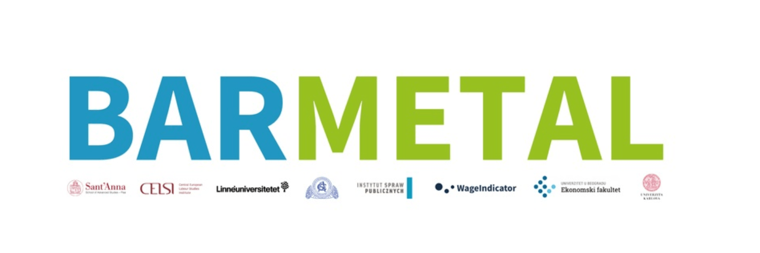

BARMETAL: Digitalization, Automatization and Decarbonization: Opportunity for strengthening collective bargaining

in the metal sector

Agenda mid-term workshop, Friday 1 December, 2023, 9.15 – 13.00 CET
Online

09:15 – 12:15 Country presentations – preliminary findings
(10mins presentation, 5 mins Q&A only clarification questions)
09:15 – 09:30 Italy

09:30 – 09:45 France
09:45 – 10.00 Romania

10:00 – 10:15 Serbia

10:15 – 10:30 Czechia

10:30 – 10:45 Slovakia

10:45 – 11:00 Break

11:00 – 11:15 Poland

11:15 – 11:30 Hungary

11:30 – 11:45 Sweden
11.45 - 12.00 Denmark

12:00 – 12.15 the Netherlands
12:15 – 12:30 Germany

12:30 – 12:40 Break

12:40 – 13.00 Discussion, brainstorming about findings, next steps and closing

Project No. 101052331 - Funded by the European Union. Views and opinions expressed are however those of the author(s) only and do not necessarily reflect those of the European Union or the European Commission. Neither the European Union nor the granting authority can be held responsible for them.

Template for preparing the BARMETAL country presentation
Max. 5 slides

- National and sectoral labour market situation (metal sector, number of workers, type of industries, etc.),
- insight into industrial relations in the sector: bargaining coverage, union density, employer density (if available),
- characteristics of the bargaining and social partnership system, type and structure of industrial relations actors, presence of other relevant actors (e.g. public employment services, the government, any bipartite or tripartite platform for negotiations,...)

- Developments in DAD: introduction dynamics, changes in production, policies
- Sectoral relevance of DAD: overview of changes in production, employment, skill levels, etc.)
- challenges (e.g. financialisation), relevant policies, measures or governance structures dealing with, national discourses on DAD

- Role of collective bargaining and social dialogue for addressing the challenges of DAD (e.g. new bargaining topics emerging? Which and in what subsectors and type of companies?)

- Case studies on how DAD impacts collective bargaining – preliminary insights into company case studies (including the justification of cases)
- overview of measures adopted in response to technological change,
- to what extent are these topics being integrated in collective bargaining,
- what are the obstacles to bargaining,
- plans for expanding bargaining with these topics,
- alternative mechanisms of implementing the identified policies if bargaining is not a viable option, etc.

- Preliminary findings and conclusions – the overall picture emerging
- how DAD creates opportunities for changes in bargaining, and how bargaining helps addressing the goals and challenges derived from DAD.
- Which part of DAD has which effect, in some cases decarbonization may prevail, while in others automatization is the most reflected in bargaining (e.g. need for upskilling workers, right to training)

