Bargaining for working conditions and social rights of migrant workers in CEE Countries (BARMIG)

KICK-OFF MEETING

October 7-8th, 2020

Participants (names and surnames, countries):

Maria Curie-Skłodowska University, Poland
Dominika Polkowska
Kamil Filipek
Karolina Podgórska
Błażej Dyczewski
Michał Nowakowski
Agnieszka Kolasa-Nowak
Emil Bartkiewicz
Magdalena Pokrzycka-Walczak (UMCS administrative officer)

Central European Labour Studies Institute, Slovakia
Marta Kahancova
Adam Šumichrast
Meszmann Tibor

Zväz elektrotechnického priemyslu SR, Slovakia
Andrej Lasz
Jana Martincova

Institute for Development and International Relations, Croatia
Hrvoje Butkovic
Ivana Rukavina
Visnja Samardzija

University of Tartu, Estonia
Jaan Masso

Other
Olena Fedyuk – Ukraine background study
Lillie Nathan – evaluator (University of Jyväskylä, Finland)

Kick-off meeting (on-line using zoom)

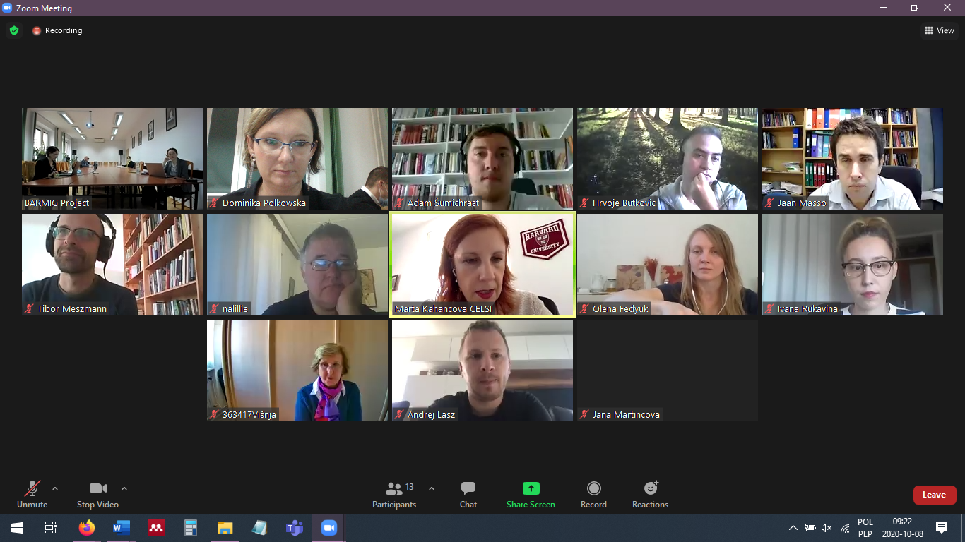

Agenda – attachment

Main points:
- Representatives of each partner presented their national BARMIG teams
- Situation in partner countries regarding implementing project’ objectives connected with COVID-19 affection
- Need to adapt project’ objectives to the new epidemic situation
- Interviews’ structures – to be discussed during next on-line meetings and chats
- Discussion on the best sources of information for interviews’ issues – each partner country should define what are now the leading dilemmas for the subject of migrant workers, so as leading sectors to be interviewed (eg. illegal migration in general and in sectors, digital economy sector, lack of basic information sources because of economic crisis caused by pandemia, proposal of media analysis)
- Discussion if information from interviewers should be anonymized
- Interviewers should be representatives of institutions from chosen sectors, not private persons, who will speak on behalf of represented organization, institution of business
- Proposed deadlines for milestones (eg. for national draft reports)
- Discussion on minimum number of reports pages
- Need to make a choice regarding tool of team communication (decision will be made during following on-line meetings)
- Methods of dissemination project’s results – to be chosen soon - website, webinar, press conferences, workshops with experts, social media, press releases
- Regarding administrative and financial issues (eg. every expenditure, in the case of doubts, should be consulted with coordinator, all institutions have their own internal accounts, dedicated only to BARMIG, internal financial procedures – in the case we have not detailed restrictions in EU guidelines - should be implemented, if there is no internal procedure regarding implementing EU projects, it is worth to create dedicated “Accounting policy” – this document is important for audit procedures and other possible controls, all documents connected with BARMIG – letters, orders, payment documents (like application for remuneration) should be printed on dedicated BARMIG paper, financial reports should be sent to BARMIG coordinator every two months - first report is needed till the end of October, coordinator should be informed about any changes in planned expenditures)
Next meeting: Zagreb (May 2021) or online via zoom (depending on the COVID19 situation)

