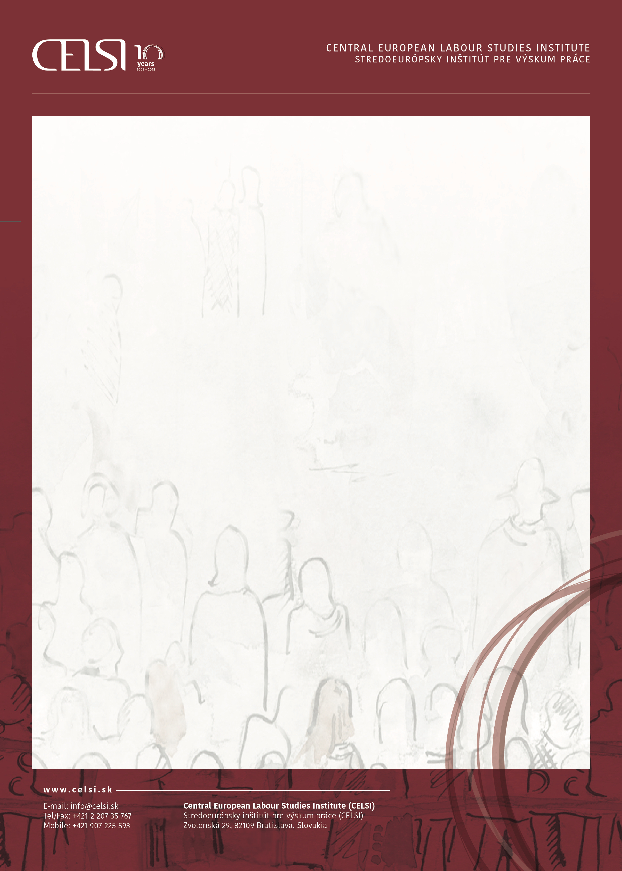

**DAY 1, MARCH 6, 2019**

|  |  |
| --- | --- |
| **14:00-14:30** | **/Introduction of the REWIR project and introduction of project partners** |
| **14:30-16:00** | **/Session 1 – Project methodology and analytical framework** |
|  | Marta Kahancová, CELSI Bratislava, Slovakia    Ziv Amir, Honorary Professor, University of Salford, the UK |
|  |  |
| **16:00-16:30** | /Break |
|  |  |
| **16:30-18:00** | **/Session 2 – Earlier research on return to work policies and actors’ strategies** |
|  | Ziv Amir, Honorary Professor, University of Salford, the UK |
|  | Mária Sedláková, CELSI Bratislava, Slovakia  Adela Popa, University Lucian Blaga Sibiu, Romania  Discussion and short inputs from each partner on their country-specific situation  on return-to-work policies and interventions |
| **19:00** | /Dinner in the city center (venue t.b.a.) |
|  |  |

**DAY 2, MARCH 7, 2019**

|  |  |
| --- | --- |
| **09:00-10:30**  **10:30-11:00**  **11:00-12:30** | **/Session 3 – Planning of project activities, meetings, deadlines, deliverables**  Mehtap Akgüç, CEPS Brussels, Belgium  /Break  **/Administrative issues, project reporting** |

Manon Jacquot, CEPS Brussels

**12:30** **/End of the event, lunch for participants**

**March 6-7, 2019, Hotel Falkensteiner, Bratislava, Slovakia**

**/REWIR kick-off meeting**

with support of the European Commission, project no. VS/2019/0075